**Laminar composites**:

**Laminar composites** include plywood, which is a laminated **composite** of thin layers of wood in which successive layers have different grain or fiber orientations. Laminates meaning: any material that is made by sticking several layers of the same material together like lamination for thinking.

**Sandwich-Structured composite:**

A **sandwich-structured composite** is a special class of [composite materials](https://en.wikipedia.org/wiki/Composite_material) that is fabricated by attaching two thin but stiff skins to a lightweight but thick core. The core is bonded to the skins with an adhesive. A variety of core **materials** is used in **sandwich** structures. The core material is normally low strength material, but its higher thickness provides the sandwich composite with high [bending](https://en.wikipedia.org/wiki/Bending) [stiffness](https://en.wikipedia.org/wiki/Stiffness) with overall low [density](https://en.wikipedia.org/wiki/Density).

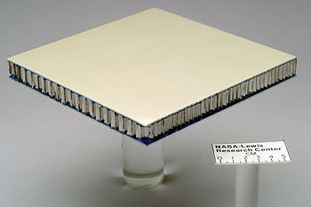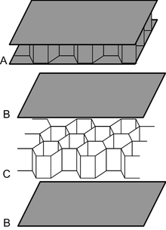

**Glass: Glass** is a non-[crystalline](https://en.wikipedia.org/wiki/Crystallinity), often [transparent](https://en.wikipedia.org/wiki/Transparency_and_translucency) [amorphous solid](https://en.wikipedia.org/wiki/Amorphous_solid). **Glass fiber** is a material consisting of numerous extremely fine [fibers](https://en.wikipedia.org/wiki/Fiber) of [glass](https://en.wikipedia.org/wiki/Glass).

**Glass fiber** is a material consisting of numerous extremely fine [fibers](https://en.wikipedia.org/wiki/Fiber) of [glass](https://en.wikipedia.org/wiki/Glass).

**Fibreglass cloth:** a fabric woven from this material or a light strong material made by bonding fibreglass with a synthetic resin; used for car bodies, boat hulls, etc. Fiberglass is lightweight, strong and less brittle.

Why bridges have triangular shapes?

A single element on a truss is called web.

**Warren truss and Pratt truss:**

**Warren Truss:**

Warren truss contains a series of isosceles triangles or equilateral triangles. To increase the span length of the truss bridge, verticals are added for Warren Truss. One of the main advantages of a Warren Truss is its ability to spread the load evenly across a number of different members. Therefore, the Warren truss type is more advantageous for spanned loads (uniformly distributed loads), but not suitable where the load is concentrated at a single point or node.

When the span length increases and the height of the truss necessarily increases, the long compression members in the top chord need bracing to minimize buckling in the vertical direction. In this case, verticals are placed from the lower chord panel points up to the mid-point of the chord member directly above.

Better streamline.

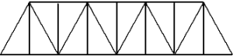

Figure 2. Warren Truss with verticals to support top chord and deck structure.

**Pratt Truss:**

A Pratt truss includes vertical members and diagonals that slope down towards the center. The vertical members are in compression, whilst the **diagonal members are in tension.**

Difficult to streamline and great in weight.

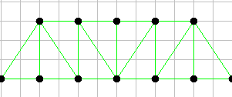

**Disadvantages**

* Not as advantageous if the load is not vertical

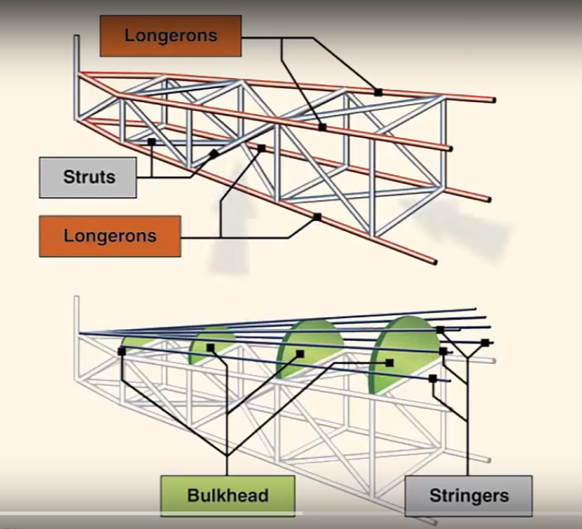

The main **disadvantage of truss structure** is lack of streamline shape. Vertical and horizontal struts are welded to the longerons to give the structure square or rectangular shaped when viewed from end. Additional structs are needed to increased strength and handle stresses from any direction. Stringers, bulkhead or formers are added to shaped the fuselage and support the covering.

**Stressed Skin:**

A stressed skin design would be a monocoque design. They do not have much internal structure by design since the skin is bearing the vast majority of the load, therefore is would be stressed-skinned.

The skin in which the shear is transferred between the stringers or longeron which run lengthwise along the fuselage and transmit tensile or compressive stress.

Equally, the wing skin is the main element for the transmission of torsional loads. When a structure is loaded, it will deform and those parts which withstand deformation most will carry most of the load. In the end, all parts which have similar stiffness will carry loads in proportion to their cross section. Since, most of an airliner’s structure is made from aluminum, it has same stiffness.

**Super Critical Airfoil:**

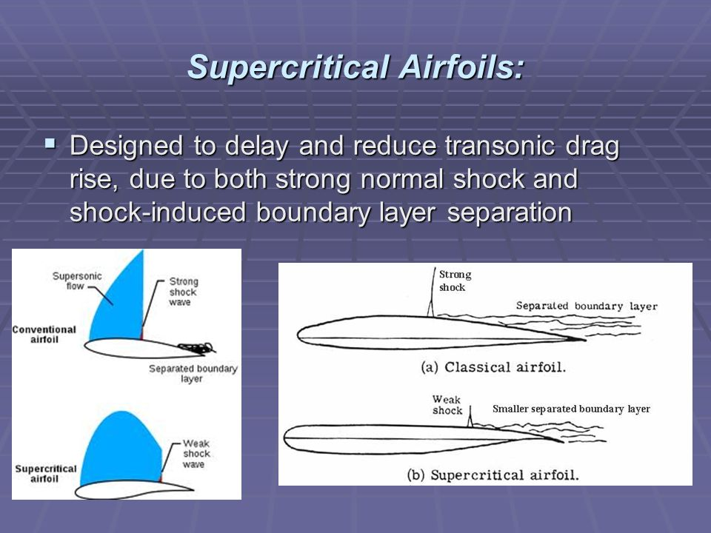

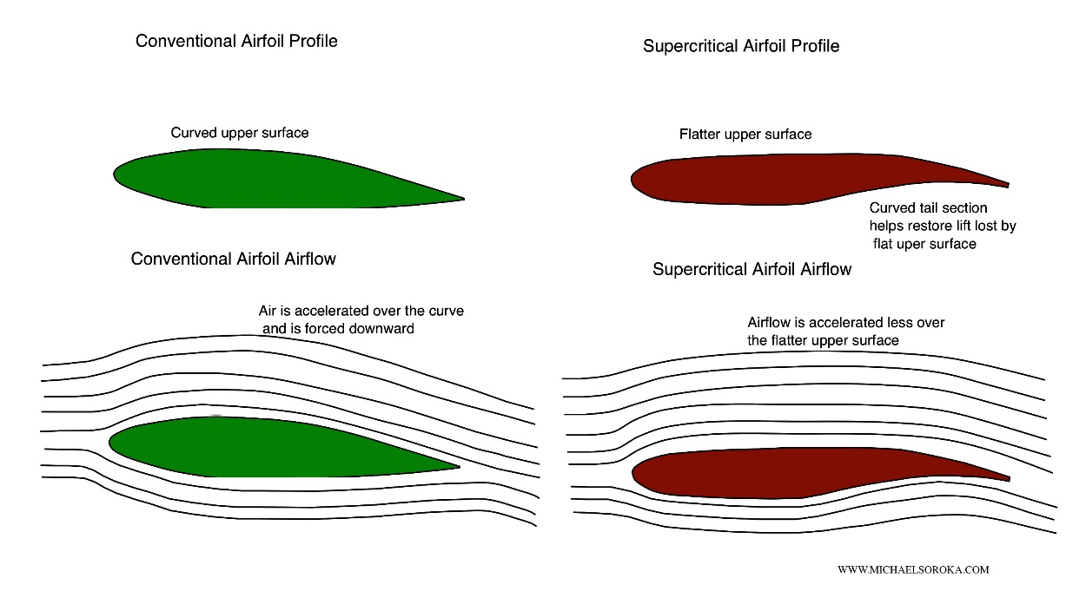

In conventional wing, at near the speed of sound, the velocity of air increase on the upper surface and becomes supersonic. This creates the shockwaves even when the velocity of aircraft has velocity less than Mach 1. The aircraft flying at this speed is called critical speed. **This shockwave causes the air after this to separate from the wing and create turbulence and drag increases and also cause vibrations.**

Supercritical wing as a flatter top and is rounder on the bottom compared to other wings. It has greater leading-edge radius and the trailing edge has a downward curve. The upper trailing edge is bent downward to restore the lift lost by flattening the upper surface.

Here, air across the top of a SCW does not speed up nearly as much as over the curved upper surface of conventional airfoil. **This delays the formation of shock wave and also reduced aerodynamic drag associated with boundary layer separation**. Lift that is lost with less curvature on the upper surface of the wing is regained by adding more curvature to the upper trailing edge. So, aircraft can cruise at higher subsonic speed and with less drag uses less fuel.

Disadvantage:

Its design is such that around 60-65 percent of the forward airfoil has negative camber which decreases the lift. Means, the mean camber line is below the chord line. To compensate it, rear 30 percent of the airfoil is made with high positive camber. **And manufacturing of such airfoils is not easy.**

**Delta Wing**:

The **delta wing** is a wing shaped in the form of a triangle. It is named for its similarity in shape to the **Greek uppercase letter delta (Δ).** Although long studied, it did not find significant applications until the jet age, when it proved suitable for high-speed subsonic and supersonic flight.

* The large root chord also provides it with a large surface area which helps to bring the minimum speed of the aircraft down.
* With sufficient leading edge sweep, a delta wing produces [vortex lift](https://aviation.stackexchange.com/questions/21069/what-is-vortex-lift/21071#21071), so [flow separation](https://aviation.stackexchange.com/questions/5048/why-does-supersonic-flight-detach-airflow-from-a-wing/5055#5055) can be turned into a means of increasing lift.
* A delta wing is naturally stable in pitch; therefore, it does not require a separate tail surface.

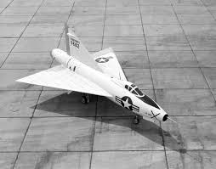

**Drawback:**

The large wing area causes more viscous drag for the same amount of lift compared to a high [aspect ratio](https://aviation.stackexchange.com/questions/716/what-dictates-the-aspect-ratio-of-an-aircrafts-wing/8797?s=11%7C0.1924#8797) wing. Swept wings have a better lift-to-drag ratio (L/D) than delta wings.

**Magnus effect:**

When the ball rotates in clockwise direction, and air is moving up. The air on the left move around the ball as the ball pushes air in right from left. And as a reaction, the air pushes ball in left direction resulting the motion of ball to the left

Magnus force is perpendicular to the flight path direction of ball and perpendicular the axis of rotation..

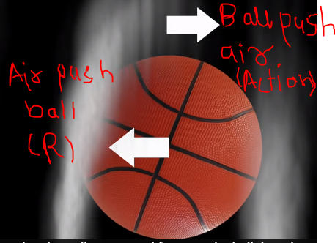

**CHAPTER 3**

**Airspeed indicator:**

**Airspeed indicator**, instrument that measures the speed of an aircraft relative to the surrounding air, using the differential between the pressure of still air (static pressure) and that of moving air compressed by the craft’s forward motion (ram pressure); as speed increases, the difference between these pressures increases as well.

Pressures are measured by a [Pitot tube](https://www.britannica.com/technology/pitot-tube), a U-shaped apparatus with two openings, one perpendicular to the flow of air past the aircraft and one facing directly into the flow. Mercury or a similar liquid fills the bend in the tube, forming parallel columns balanced by the air pressure on each side. When static and ram pressure are equal, the columns have the same height. As the ram pressure increases, mercury on that side of the tube is pushed back and the columns become imbalanced. The difference between the two columns can be [calibrated](https://www.merriam-webster.com/dictionary/calibrated) to indicate the speed; this value, called the indicated airspeed, may be given in knots, miles per [hour](https://www.britannica.com/science/hour), or other units.

**Since the airspeed indicator is calibrated at standard temperature and pressure, its readings are inaccurate at different temperatures and altitudes**. An (uncorrected) indicated airspeed is still used to estimate an aircraft’s tendency to stall. **Instruments that electronically correct for altitudinal differences and temperature give the true airspeed, which is used to calculate the aircraft’s position.** In faster aircraft, indicators that measure airspeed relative to the [speed of sound](https://www.britannica.com/science/speed-of-sound-physics), called [Machmeters](https://www.britannica.com/technology/Machmeter), are used.

**True Air-speed:**

It’s the aircraft speed relative to the air in which it’s flying**. Airspeed indicator doesn’t measure speed, it measures pressure.** Airspeed indicator reads accurately at sea level in standard conditions but as you start to climb, pressure then they become non-standard and temperature goes on changing and your airspeed indicator doesn’t report accurate speed. That’s because your airspeed indicator reports a slower speed than true airspeed as density is decreased.

**Sink rate:**

 Negative rate of [altitude](https://en.wikipedia.org/wiki/Altitude) change with respect to time. [Rate](https://en.wikipedia.org/wiki/Temporal_rate) of decrease in altitude is referred to as the **rate of descent** (**RoD**) or **sink rate**.

Stall: The condition in aircraft where the increase of AOA of wing do not increase the lift.

**Taxi phase:**

The taxi phase begins when the aircraft moves aft its gate position. Gate position of the aircraft is that position where aircraft is loaded (boarding of passenger) and is in parking. In taxi phase brake is checked, various flight controls like ailerons, de-icing, etc. The maximum speed allowed is 30 knots and max. 10 knots for turn. The taxi phase ends when the aircraft takes its holding position. Holding position is the position when the aircraft is waiting for its turn to be on the runway. **In summary, taxi phase** begins from the point where aircraft is loaded to the point where the aircraft is waiting for its turn to be on the runway.

**Line-up** is the phase when the aircraft enters the runway and the fuselage of the aircraft comes in line with the centerline of the runway.

**Taxing**, also sometimes written "taxying", is the movement of an [aircraft](https://en.wikipedia.org/wiki/Aircraft) on the ground, under its own power, in contrast to towing or push-back where the aircraft is moved by a tug. The aircraft usually moves on wheels, but the term also includes aircraft with skis or [floats](https://en.wikipedia.org/wiki/Buoyancy) (for water-based travel).

**G-force:**

In 1948, Stapp decided to test the G-force a body could withstand so he accelerated to 632 miles per hour in five seconds and stopped in 1 sec. The machine was like a rail in a rail-track. He experienced 46.2 G’s. For an instant, his 168 (76.2035) pound body had weighted over 7700 pounds (3492.66).

As we know, acceleration is not only due to chance in speed over time in linear direction but acceleration also occur due to change in direction.

The G-force tolerance depends upon the direction of G-forced experienced:  front-to-back, side-to-side, or head-to-toe and vice-versa. Stapp encountered front-to-back and back-to-front which are not so dangerous. But vertical forces are different entirely. Normally, blood pressure is 80-120 mm of Hg of an average person to overcome 1G-force exerted by Earth on our body (blood). When we experience, 2 G from head-to-toe then the blood pressure has to be increased to supply the brain the blood and similarly for higher G-forces. Most pass out at 4 to 5G. But if its toe-to-head then average person pass out at mere 2 to 3G as too much blood rushed to our heads. **For long time it can be dangerous.**

**During banked turn, the change in velocity direction causes to experience extra acceleration for G-force i.e. centrifugal force acting away from center of turn.**

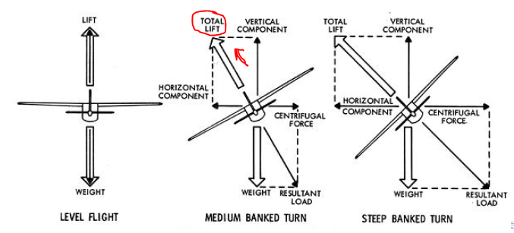

**During banked the lift direction also change, this is because the force exerted by pressure of air is always perpendicular to the surface. So, the lift is also perpendicular to surface or wings.**

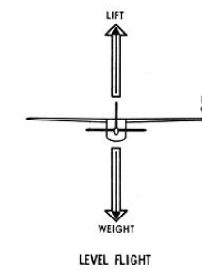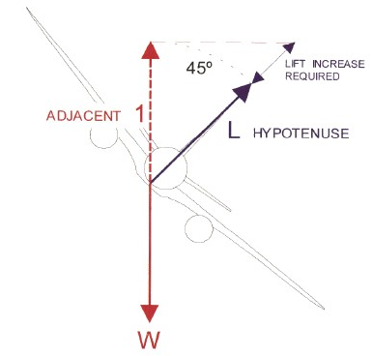

When the plane is banked, then the vertical lift changes it direction to hypotenuse L, but to maintain LEVEL FLIGHT vertical weight must be balanced by vertical component of lift. As, vertical lift (L) is replaced by vertical component (Lcos(theta)) of lift which is less than the lift (L) so plane will lose the altitude. **So, to balance the weight the speed must be increased to increase the lift value.**

**Since, the load factor is the lift to the weight.**

**n=L/W**

**In banked turn (FOR LEVEL FLIGHT) = lift value is increased due to increase in speed to maintain level flight but the vertical weight remain same so load factor also increases.**

**Since, the flight must level so the resultant weight must be balanced by total lift so total lift can be replaced by resultant weight. So,**

**n=resultant weight or load/ (vertical weight =vertical comp of lift) = L/Lcos(theta) So, n=1/cos(theta)**

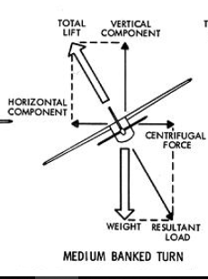

**Cruise** is a flight phase that occurs when the [aircraft](https://en.wikipedia.org/wiki/Aircraft) levels after a [climb](https://en.wikipedia.org/wiki/Climb_(aeronautics)) to a [set altitude](https://en.wikipedia.org/wiki/Cruising_altitude) and before it begins to [descend](https://en.wikipedia.org/wiki/Descent_(aeronautics)).

**Flaps:**

Flaps do two things: They increase lift, and increase drag. Flaps increase lift by extending the camber of the wing, which increases the maximum lift coefficient. This allows the aircraft to fly at a lower speed without stalling.  Increased lift means increased lift-induced drag, and when extended, the flaps themselves also create parasite drag.  Therefore, flaps can be used to allow the plane to fly at a lower speed (lift effect) and/or help slow the airplane down (drag effect).

Only a small amount of flap is typically used for takeoff, usually no more than 5°.  The purpose of takeoff flaps is typically to shorten the takeoff roll without increasing drag, so less flap is desired. Normally, flap settings between 0-25 degrees will noticeably increase lift more than drag, ideal for takeoff. Flap setting beyond 25 will increase drag much than lift, ideal for landing.

For landing, full or close to full flaps is typically used (typically between 30° and 40°). This reduces the landing roll and reduces wear on the wheel brakes.

**Flaperon:**

A **flaperon** (a [portmanteau](https://en.wikipedia.org/wiki/Portmanteau) of [flap](https://en.wikipedia.org/wiki/Flap_(aeronautics)) and [aileron](https://en.wikipedia.org/wiki/Aileron)) on an aircraft's wing is a type of [control surface](https://en.wikipedia.org/wiki/Flight_control_surfaces) that combines the functions of both flaps and ailerons. Some smaller [kitplanes](https://en.wikipedia.org/wiki/Kitplane" \o "Kitplane) have flaperons for reasons of simplicity of manufacture, while some large commercial aircraft may have a flaperon between the flaps and aileron.

In addition to controlling the [roll](https://en.wikipedia.org/wiki/Flight_dynamics_(aircraft)) or bank of an aircraft, as do conventional ailerons, both flaperons can be lowered together to function similarly to a set of flaps.

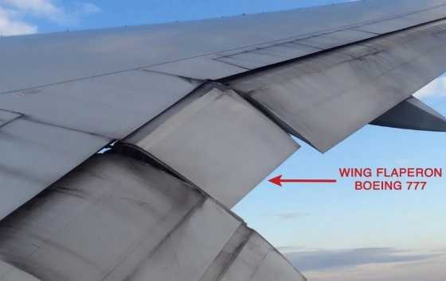 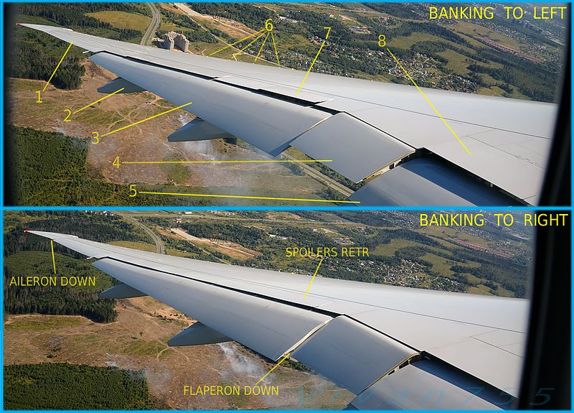

**Flow separation:**

 Boundary layers can be either [laminar](https://en.wikipedia.org/wiki/Laminar_flow) or [turbulent](https://en.wikipedia.org/wiki/Turbulent_flow). A reasonable assessment of whether the boundary layer will be laminar or turbulent can be made by calculating the [Reynolds number](https://en.wikipedia.org/wiki/Reynolds_number) of the local flow conditions. **Flow separation occurs when the boundary layer travels far enough against an**[**adverse pressure gradient**](https://en.wikipedia.org/wiki/Adverse_pressure_gradient)**that the speed of the boundary layer relative to the object falls almost to zero so it doesn’t have enough momentum to go against back pressure. (Further explanation in copy).**  The fluid flow becomes detached from the surface of the object, and instead takes the forms of [eddies](https://en.wikipedia.org/wiki/Eddy_(fluid_dynamics)) and [vortices](https://en.wikipedia.org/wiki/Vortex).

In [fluid dynamics](https://en.wikipedia.org/wiki/Fluid_dynamics), an **adverse**[**pressure gradient**](https://en.wikipedia.org/wiki/Pressure_gradient) occurs when the [static pressure](https://en.wikipedia.org/wiki/Static_pressure) increases in the direction of the flow as in airfoil where velocity goes on decreasing and pressure goes on increasing behind the maximum thickness of airfoil region.

Boundary layer separation occurs when the portion of the boundary layer closest to the wall or leading-edge reverses in flow direction. The separation point is defined as the point between the forward and backward flow, where the shear stress is zero.

boundary layer separation on bluff body
 

boundary layer separation on blunt body
 

**Landing and Take-off:**

During take-off and landing the airplane’s velocity is relatively low. On takeoff, we want high lift and low drag, so the flaps will be set downward at a moderate setting. During landing we want **high lift and high drag**, so the flaps and slats will be fully developed.

But during landing it is necessary to have a much lower airspeed, in order that the pilot has much better control and the landing can be successfully managed in the limited length of the runway. Lift depends on airspeed; since airspeed during landing is going to be (myself=very) low, lift is going to be low. **An amount of lift nearly equal to the weight of the aircraft has to be provided**, so something has to be done to augment (increase) the poor lift at landing speeds.

**“high lift”;** **it actually means is “higher lift than can be provided by that wing at that low airspeed.” So we use high-lift devices.**

When the wheels touch down, we want to decrease the lift (to keep the plane on the ground), so the spoilers are used to create additional drag to slow down the plane.

When slat are used then the slat moves slightly down which increases the effective camber of the airfoil and the area of the airfoil is increased which increases the lift.

**Lift Augmentation:** <https://elearnstation.com/scenari/AERODYNAMICS/co/module_THEORY_OF_FLIGHT_7.html>

Augmentation= the action or process of making bigger in size or amount or simply increase.

**A**[**Lift**](http://www.futura-sciences.us/dico/d/physics-lift-50002593/)**augmentation system** is a device installed on the wing of an [aircraft](http://www.futura-sciences.com/fr/services/fonds-decran/homme/avion/) to produce an increase in lift at a given speed. It is useful at low speed because it reduce the stall speed (the plane can [fly](http://www.futura-sciences.us/dico/d/zoology-fly-50003949/) more slowly or how slowly plane can fly maintaining level flight).

It can be installed on the leading [edge](http://www.futura-sciences.us/dico/d/computer-science-edge-50004845/) of the wing ("leading edge slats") or on the trailing edge ("wing flaps"). A lift augmentation device can be fixed or mobile. When fixed, it gives STOL (Short Take Off and Landing) capability to the aircraft, but cruising speed is reduced. (With the use of flaps and slats more drag also increased so the velocity also decreases = mine answer).

Other techniques for increasing lift are vortex generators, wing fences and discontinuous leading edge.

**PRINCIPLE OF LIFT AUGMENTATION SYSTEM:**

The lift must be temporarily increased at the time of takeoff and landing. It is on this principle that automatic or controlled devices known as high-lift devices are integrated into the aerodynamic structure of the plane.

**1.1. Effect on the wing surface area (S):**

The increase in wing surface area S is primarily obtained by the deployment of moveable surfaces at the leading edge and trailing edge of the wing

**1.2. Effect on the coefficient of lift (CL):**

There are various means to increase the coefficient of lift:

* By changing the curvature of the aerofoil, thus the chord line and the angle of incidence. Indeed it is the deployment of moveable surfaces which changes the geometry of the aerofoil.
* By actions on the boundary layer: the layers of air on the upper surface have a tendency to separate from the aerofoil at low speeds. (Explanation in copy) The remedy consists of energizing the boundary layer so that it adheres to the skin of the aerofoil, thus producing lift i.e. increasing air velocity near the surface.
  1. **LEADING EDGE LIFT AUGMENTATION SYSTEMS:**

The wind tunnel tests showed that the lift coefficient of an aerofoil depends on several parameters. By increasing the camber of the aerofoils while increasing the wing surface area, lift will be improved for low speeds.

**Leading edge slats:**

Slats are aerodynamic surfaces on the leading edge of the wings of fixed-wing aircraft which, when deployed, allow the wing to operate at a higher angle of attack.

While passing through the convergent channel, the airflow is accelerated on the lower surface towards the upper surface thus making it possible to limit the separations of the boundary layer where the angle of attack is high as well as on the rest of the aerofoil. Air moves from lower surface to upper surface due to the difference of pressure between them.

**Variation of CL at leading edge according to the angle of attack:**

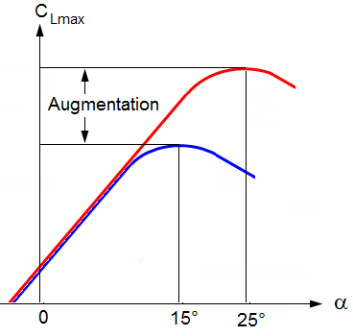

All the lift augmentation systems at the leading edge make it possible to increase the CL max by increasing the angle of attack. So by deploying slats, an aircraft can fly more slowly or ‘take off and land in a shorter distance’.

**Landing and take off positions, flap extended:**

The high pressured air coming from the lower surface emerges at high speed on the upper surface and accelerates the boundary layer. The lift is increased.

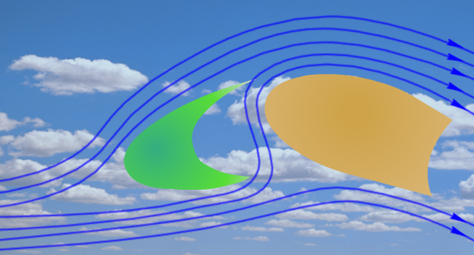

b. **TRAILING EDGE LIFT AUGMENTATION SYSTEMS:**

**Trailing edge flaps:**

Flaps give a new shape to the wing but their deployment is limited by the separation of the boundary layer. The presence of slits, whose form and position were calculated and studied by engineers, accelerates the airflow on the upper surface in order to make them stick to the aerofoil .

* **The split flap:**

This type of flap affects the flow only on the lower surface. The increase in pressure caused by the extension of this device at the lower surface increases lift. The significant wake that it produces also causes a great increase in drag.

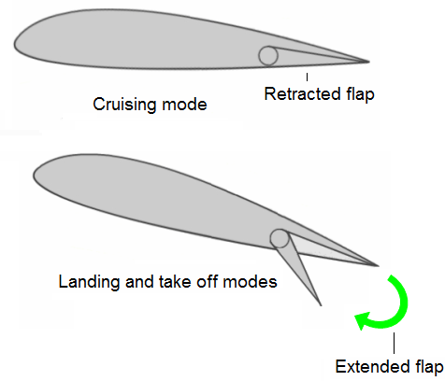

* **The plain or camber flap:**

This flap affects the airflow on the lower surface and the upper surface of the aerofoil by modifying its shape without much increase in drag. The risk in separation of the boundary layer is however increased.

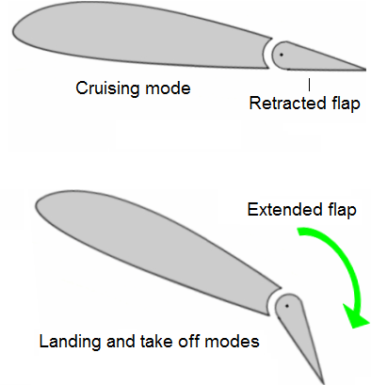

* **The Fowler flaps:**

The extension and retraction of this flap are carried out simultaneously by moving its axis of rotation. This change can cause a great increase in the wing surface area.

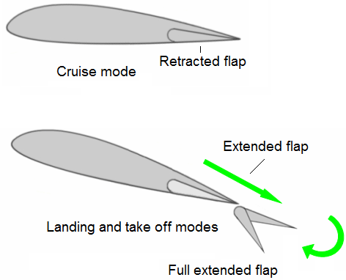

* **The slotted flap:**

The prevention of the separation of the boundary layer is achieved by the presence of a slot between the fixed part of the wing and the leading edge of the flap causing an acceleration of the airflows.

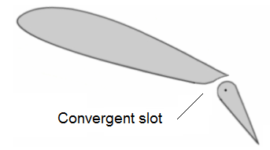

* **Multi slotted flaps:**

With this type of flap acting itself as a lift augmentation system, the increase in lift is very significant. The airflow separation is delayed to a maximum by the presence of converging slots which therefore control the boundary layer.

The shape of the flaps changes gradually to adapt their position to the flight configuration.

Below: Double slotted flap:

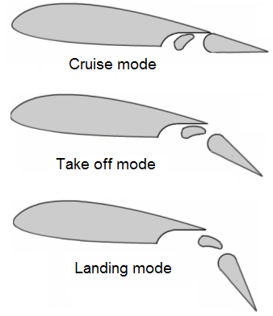

Below: Double slotted flap:

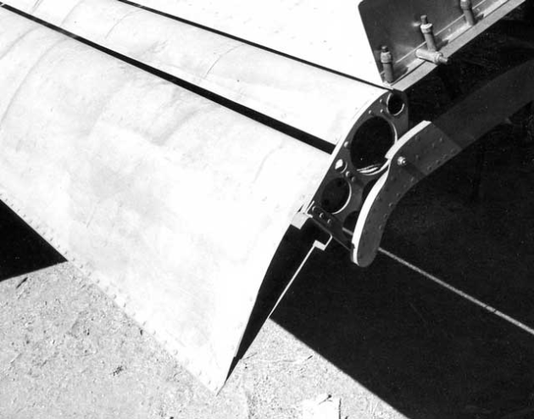

Below: Triple slotted flap

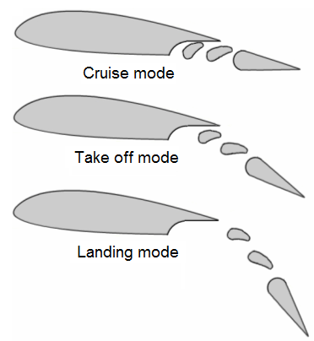

Below: B 747 triple slotted flap

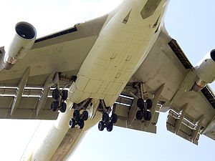

40% Increase CLMAX Critical Angle 20o
SLOT
A leading edge slot is a fixed aerodynamic
feature of the wing of some aircraft...

**CHAPTER 4**

**Forces on wings:**

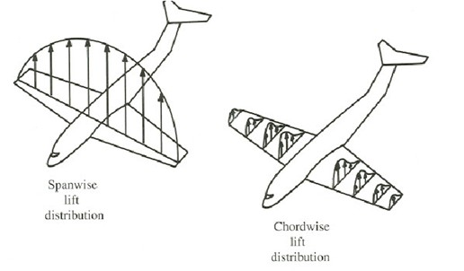

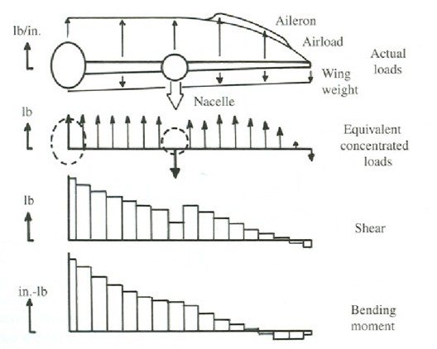

**When fueling airliners, why is fuel filled first in the tanks in the wings and then the center tanks? And why do they use fuel from the center tanks first and then from the tanks in the wings?**

Let's say in our airliner each wing tank holds 100 units (200 total for both tanks), and the center tank holds 200 units, and you have a flight that needs 200 units of fuel.

* Correct scenario: By filling only the wing tanks, the weight of fuel in the wings will counter the bending of the lift.
* Incorrect scenario: By filling only the center tank, the wings will bend a great deal (maybe even beyond their design limit). This is not good, and even if it is within the design limits, the repeating [avoidable] stresses will shorten the [plane's lifespan](https://aviation.stackexchange.com/q/2263/14897).

**Example for order of use (schedule):**

Our flight needs 300 units, based on the above, we will fill the wing tanks, and fill half the center tank.

* Correct order: By emptying the center first, we have extended the duration of the wing bending relief.
* Incorrect order: By emptying the wings first, we lose the wing bending relief, while the plane is still heavy.

Resultant aerodynamic force is perpendicular to chord but the ***lift is perpendicular to the related wind.***

**Lighting strike in airplane:**

When the lighting strikes on the airplane, as airplane skin being mainly alloy i.e. conductor so the charge gets distributed and charge are stored on the outer surface as more space, they get between two same charge electrons outside. So, if lighting strikes from one end (mainly nose) then it exits from other end (like tail and wings tip) plane acting as only path. Continuous electrical contact around the entire periphery of the parts.

**Now the plane is covered with composite material but they get a special layer of conductive mesh made from copper foil.**

**And, for also the internal system and cables are also covered with copper meshes**. **The fuel tank gets filled with neutral gas so that they don’t catch fire.** And to lower the chances of coming into lightning bolt path, **there are special static eliminators installed on the wing’s edges. Static discharge flows off them and out into the air.** Due to which plane always stays neutrally charged and doesn’t attract lighting in the first place. If lighting does hit, it passes through static eliminator. The lighting may leave small melted holes no more than 1 cm at entry and exit point.

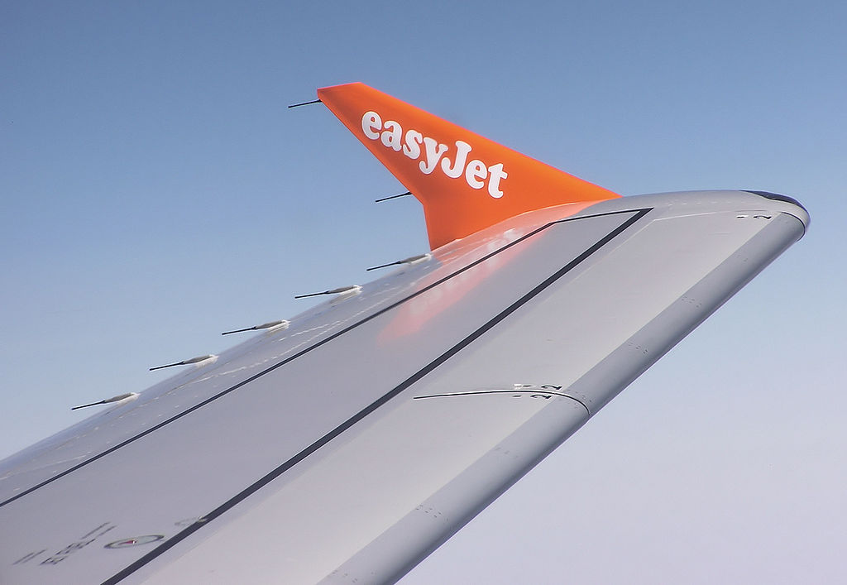

**Lighting is 5 times hotter than the surface of sun.**

Airplane is prevented by the concept of Faraday Cage. Car also acts as the Faraday Cage. Faraday cage also block the electromagnetic radiation. So, military also uses it for keeping the sensitive electronic components from safe from emp (Electro-magnetic pulse).

**Lighting is the collection of electrons and it is also searching for the easiest path to the ground.** As metal provides easier path to electrons i.e. metal provide so much least resistant to electrons so they **glide over the metal rather than penetrating the surface** to the ground. Also work for current. E.g. cat in a closed container passing current to the ground.

When you are in open ground and there is lighting do not stand up, as lighting may pass from you rather than air and soil so you acts as shortcut for lighting and if u lie down then the current will pass through you to heart other vital parts current coming from nearby strike. So best way is to sit and keep feet near together so current may go from one feet to the next feet missing vital parts.

**Wing box:**

The wing box of an airplane is the structural component from which the wings extend. It is usually limited to the section of the fuselage between the wing roots

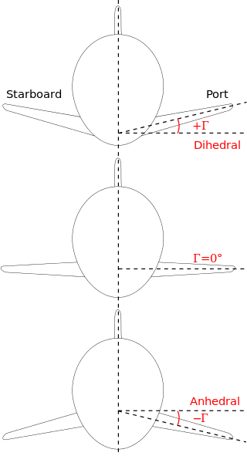

**Bracing:**

**Bracings are structural components or assemblies that are intended to prevent buckling or reduce the effective unsupported length of columns, truss chords, towers and other members or structures loaded in compression.** In particular cases, the same bracing is also used to withstand externally applied loads.

Less stiffness allows for greater deformations, which in turn results in more force on the bracing because with less force the element will start to deform and it’s now the brace element job to withstand the deformation.

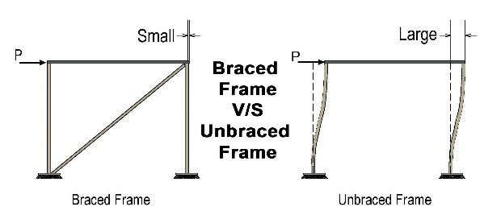

**Stiffness** is the extent to which an object resists deformation in response to an applied force. The complementary concept is flexibility or pliability: the more flexible an object is, the less **stiff** it is.

**Crack Stopper:**

When the crack is formed at the lower surface and moves to upper portion then the crack stopped forming at the splice part. In this way the moving of crack further up is stopped.

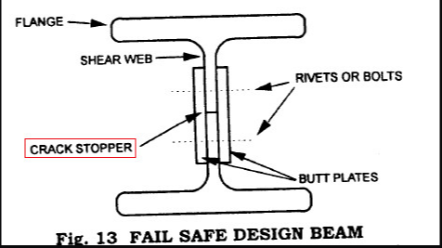

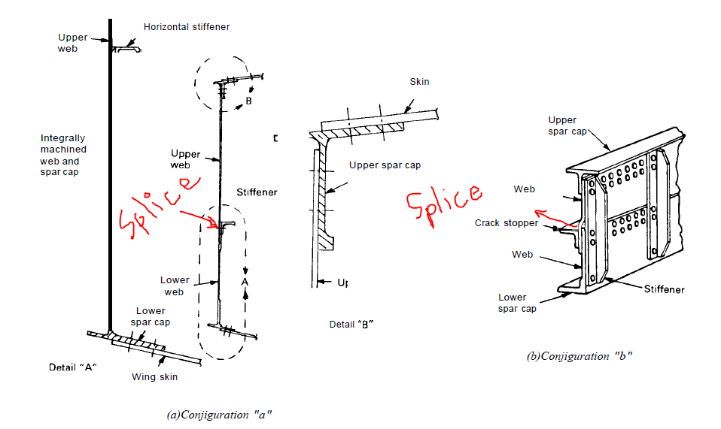

In general, crack can also be stopped by drilling the hole in the crack starting point or crack tip. But this is not important in this lesson.

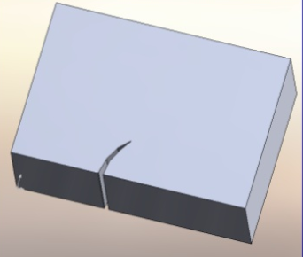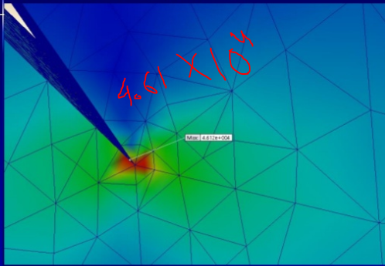

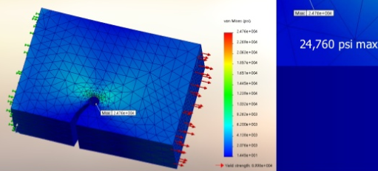

**Ribs and bulkhead:**

Very important drawing gives the idea of assembly of the parts.

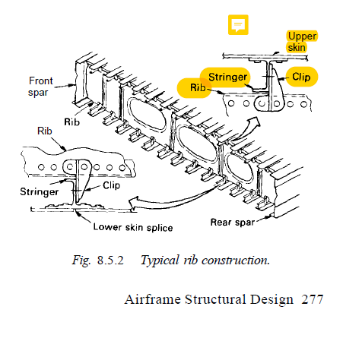

**Nacelle:**

A **nacelle** ([/nəˈsɛl/](https://en.wikipedia.org/wiki/Help:IPA/English) *[nə-SEL](https://en.wikipedia.org/wiki/Help:Pronunciation_respelling_key" \o "Help:Pronunciation respelling key)*) is a [housing](https://en.wikipedia.org/wiki/Enclosure_(electrical)), separate from the [fuselage](https://en.wikipedia.org/wiki/Fuselage), that holds [engines](https://en.wikipedia.org/wiki/Aircraft_engine), fuel, or equipment on an [aircraft](https://en.wikipedia.org/wiki/Aircraft).

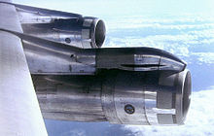

Engines in nacelles on a [Boeing 707](https://en.wikipedia.org/wiki/Boeing_707)

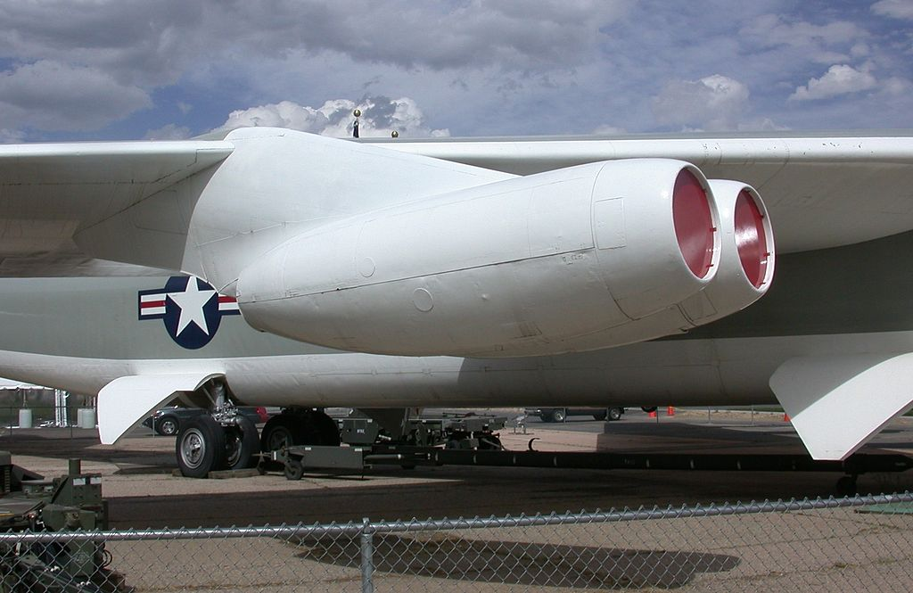

Twin-engine nacelle on a [B-52](https://en.wikipedia.org/wiki/B-52) Stratofortress

Flap track: <https://www.youtube.com/watch?v=Wlqw7caVle4>

Also: <https://www.youtube.com/watch?v=kKDMjc3l_gw&feature=youtu.be&t=7s>

The projecting pod-like structures underneath the wings are known as **flap track fairings.**

**Fairing:** an external metal or plastic structure added to increase streamlining on a high-performance car, motorcycle, boat, or aircraft.

The **flap track fairings** serve two purposes.

* Firstly, they contain and protect the flap extending and retracting mechanism.

Each fairing consists of two parts. One part moves down with the flaps while the other remains stationary.

The flaps are actuated using a complex set of structures and joints enclosed inside the fairings, which are hydraulically operated.

* The second purpose of the fairings is to reduce drag while cruising at transonic speeds, and ultimately reduce fuel consumption.

Here’s a picture [of a wing] with and without the flap fairings from a wind tunnel test at transonic flight. The flow is visualized using oil particles. The pronounced white line in the left picture was the position of the shock. The picture on the right illustrates how the fairings mitigate (meaning decrease) that shock wave and render the flow smooth to a certain extent.

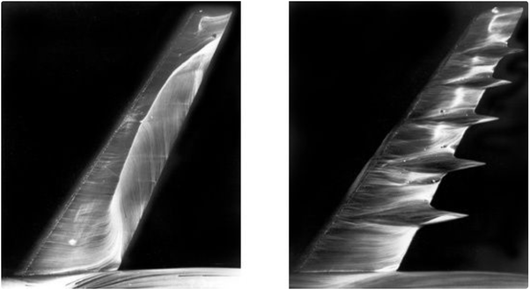

As such, the **flap track fairings** are also known as ***anti-shock bodies*.**

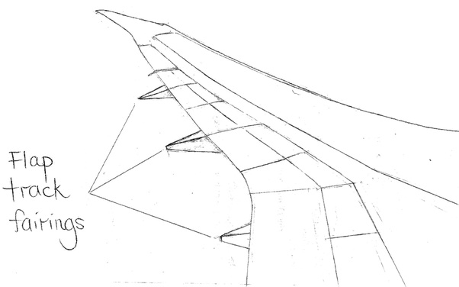

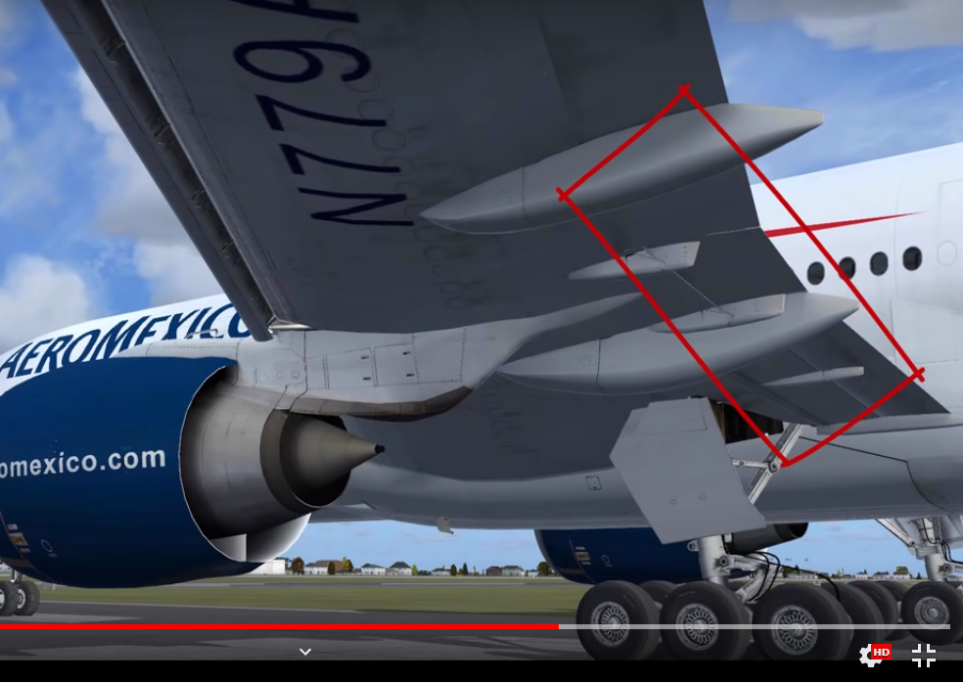

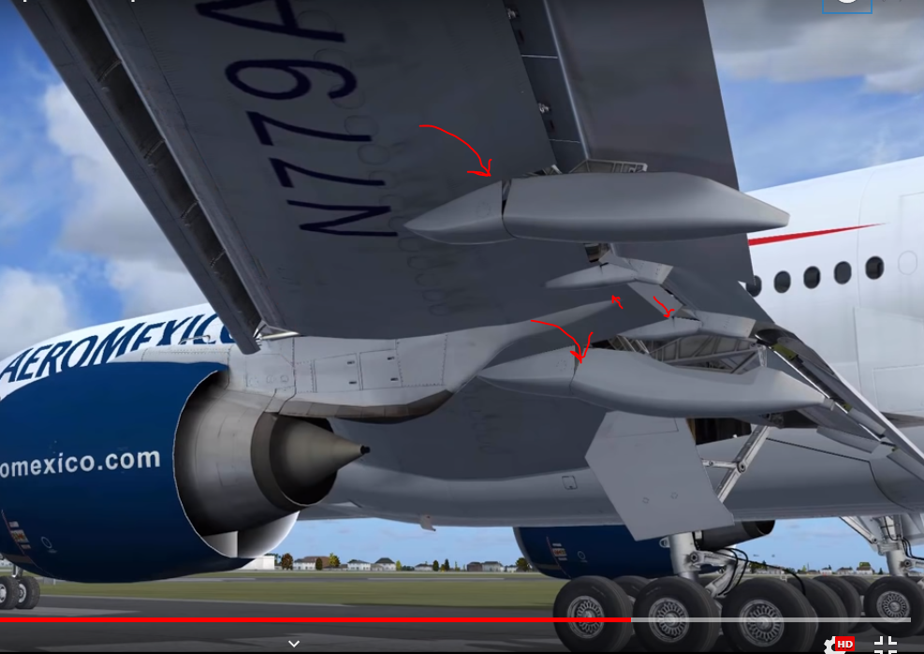

**Chapter 4:**

**Strut:**

Struts generally work by resisting longitudinal [compression](https://en.wikipedia.org/wiki/Compression_(physical)), but they may also serve in tension.

Bracing struts and wires of many kinds were extensively used in early [aircraft](https://en.wikipedia.org/wiki/Aircraft) to stiffen and strengthen, and sometimes even to form, the main functional airframe. Throughout the 1920s and 1930s they fell out of use in favour of the low-drag [cantilever](https://en.wikipedia.org/wiki/Cantilever) construction. Most aircraft bracing struts are principally loaded in compression, with wires taking the tension loads.

Struts have also been widely used for purely structural reasons to attach engines, [landing gear](https://en.wikipedia.org/wiki/Landing_gear) and other loads. The oil-sprung legs of retractable landing gear are still called [*Oleo struts*](https://en.wikipedia.org/wiki/Oleo_strut).

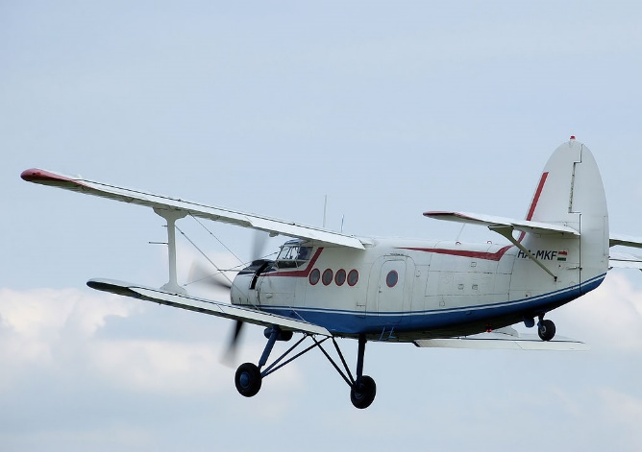

Struts on the [undercarriage](https://en.wikipedia.org/wiki/Landing_gear), [wings](https://en.wikipedia.org/wiki/Wing) and [tailplane](https://en.wikipedia.org/wiki/Tailplane" \o "Tailplane) of an [Antonov An-2](https://en.wikipedia.org/wiki/Antonov_An-2) [biplane](https://en.wikipedia.org/wiki/Biplane)

**Wings:**

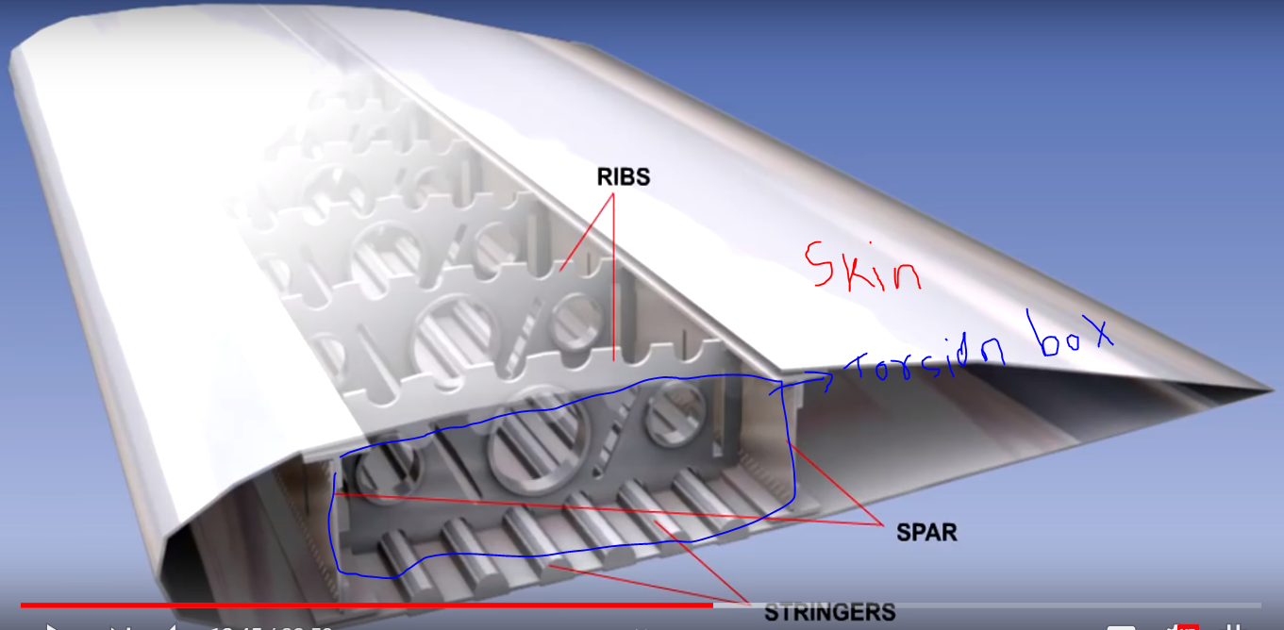

Torsion box acts as beam but is considerably lighter than a solid beam of same size without losing much strength and here top and bottom cover acts as surface for it. It is designed to resist [torsion](https://en.wikipedia.org/wiki/Torsion_(mechanics)) under an applied load. The principle is to use less material more efficiently.

* **Aircraft thickness of skin varies from 2 to 4 mm.**
* **Frames in the fuselage are also called formers.**

The **wing box** of an **airplane** is the structural component from which the **wings** extend. It is usually limited to the section of the fuselage between the **wing** roots.

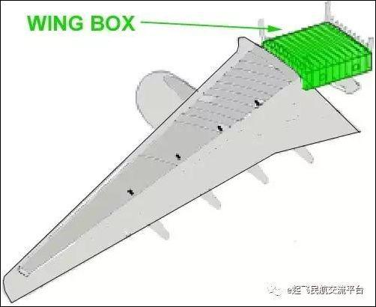

* Skin takes the loads due the difference in air pressure and due to the mass and inertia of the fuel in the wing tanks.

**Stringer’s** are span wise members which gives the wing rigidity by stiffening the skin in compression. In most modern aircraft, they are formed by machining integral ridges into the skin i.e. stringer and skin as the single part.

**Ribs** maintain the airfoil shape of the wing. Supports spars, stringers and skin against buckling and pass concentrated loads from the engines, landing gears into the skin spars. Ribs often have holes cut into them reducing weight and these holes are usually flanged to help stiffen the rib. The major structural components of the wings are generally manufacture from the aluminum alloy.

**Flange:** It is used for strengthen the structure.

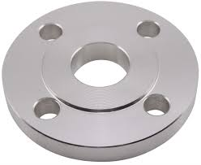

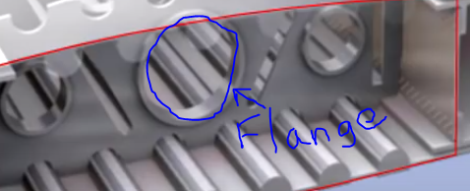

Fuel added to the wing will decrease the wing bending load due to lift.

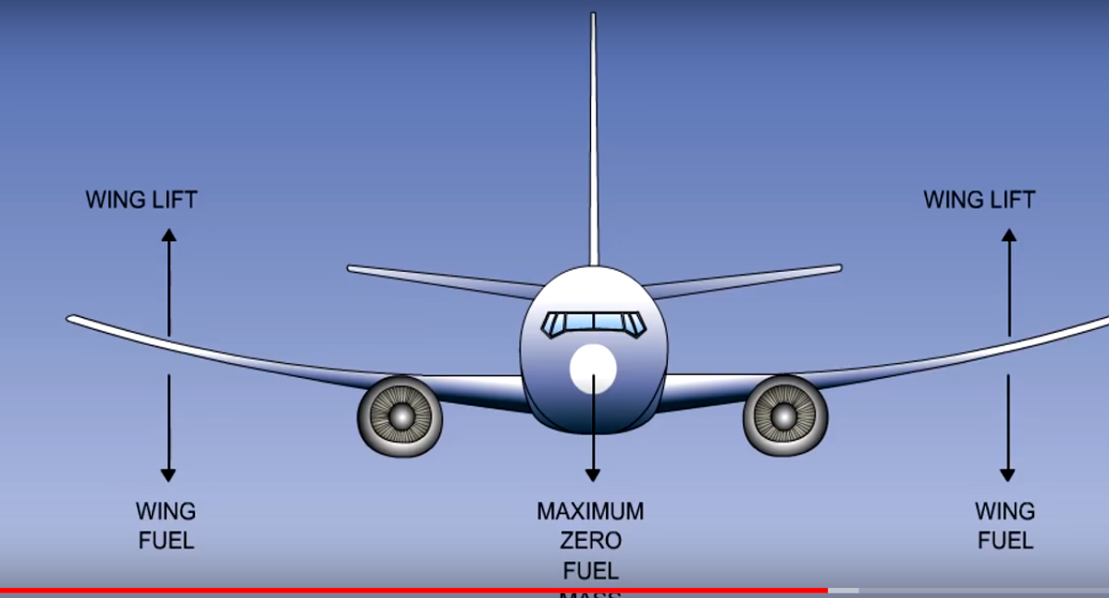

**Fuel tank:**

 In many cases there is a tank inside the wing. In some cases, it can be stored in a soft bladder in the wing and in other cases the wing its self is the tank.

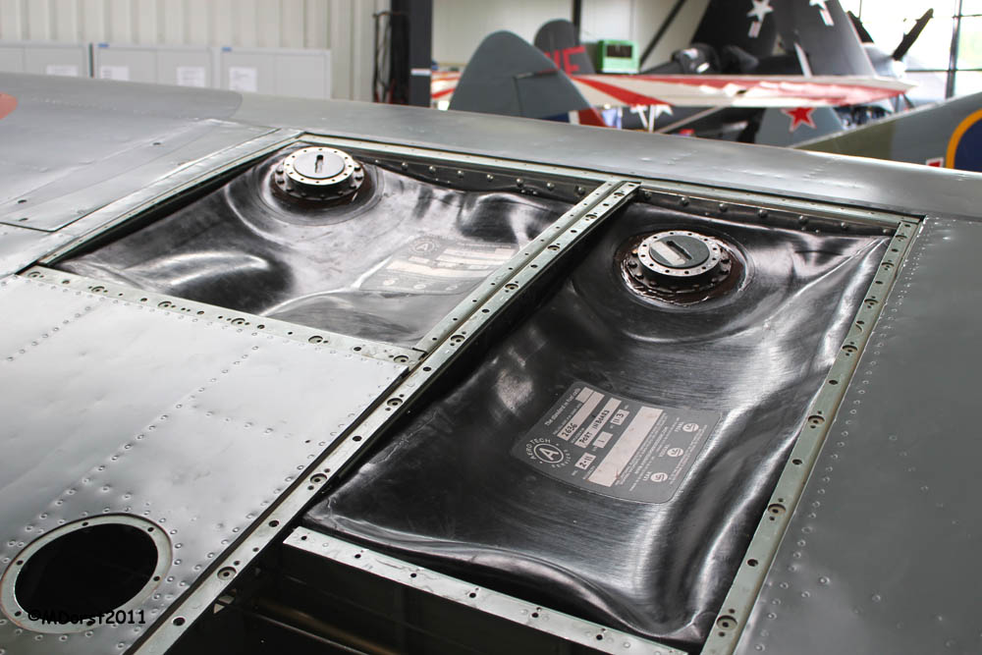

**Air-brakes:**

These are aerodynamic brakes in the form of panels which are deployed in a symmetrical way in the airflow. They can be deployed at various positions depending on the amount of braking required.

Below: Air-brakes extended:

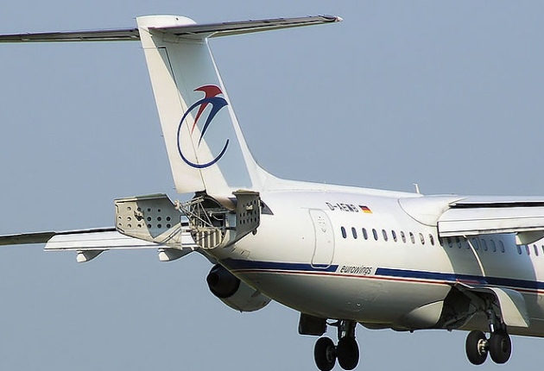

The air-brakes considerably increase the aerodynamic resistance of the plane.

These devices make it possible to change altitude quickly and to maintain a cruising altitude while approaching the airport, thus diminishing the fuel consumption.

**Air brakes are designed so that lift is not considerably decreased.** At touch down, during landing, while fully extended, they contribute with the help of the spoilers to decreasing the landing roll.